Table of Contents
General 2
Space: 2
Light: 2
Humidity-Temperature: 2
Jigs & Fixtures: 2
Plywood Usage: 2
Horizontal Tail 3
Ribs: 3
Elevator: 3
Installing Carbon In The Caps: 3
Hinges: 4
Female hinges: 4
Elevator Horn: 5
Stabilizer Mount Holes: 5
Elevator D-Tube: 5
Covering: 5
Vertical Tail: 5
Spars: 5
Rudder Horn: 6
Wings: 7
Carbon Spar Caps: 7
Installing the Carbon: 8
Wing Ribs: 8
Center Ribs: 8
Assembly: 9
D-tube Skin: 9
Mating Wings And Flaperons: 10
Covering: 10
Flaperons: 10
Ribs: 10
Flaperon Spar: 10
Flaperon Ribs: 13
Assembly Of Ailerons: 13
Tail Boom: 14
Longerons: 14
Mold: 14
Bulkheads: 14
Graphite Cloth: 14
Assembly: 14
Tail Cone: 15
Control Tubes 15
Rudder Pedals: 15
Wheel Brackets: 15
Pilot Pod: 15
Kevlar: 16
Tail Wheel Spring: 16
Doors: 16
Pulley Brackets: 16
Canopy: 17
Frames: 17
Nose Cone: 17
Tow Hook: 17
Stabilizer Brakets: 18
Materials: 18
Foot Launch: 18
Improved Stabilizer Mount Brackets: 19
Spoiler: 20
Top and Side View: 20
Detail A-A: 21
Spoiler Hinge Detail: 21
Spoiler Lever: 22
Spoiler Operation: 22
Detail B-B: 22
Detail C-C: 23

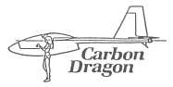
BUILDING THE CARBON DRAGON

General

Space:
The area needed to build the Carbon Dragon is set by the fact that one wing is about 22'(feet) long, and you have to work around the ends. So you need a minimum length of about 25'. More is always better, but my shop is 20' x 14' with an 8' x 5' extension and has proven to be adequate.

Light:

You need good lighting. I have 2 double 8' florescent tube fixtures and use a drop light occasionally.

Humidity-Temperature:
All glass carbon work is best done in low humidity and temperature control is a must. It is important that glass-carbon-epoxy layup be done at 70° to 80° F. The material itself is heated to a level even higher. We put our roving and epoxy in a cardboard box with lightbulbs inside and keep it at about 90° to 110° overnight before lay-up.

Jigs & Fixtures:
The main jig needed to build Carbon Dragon is the assembly table. We built ours of ½" plywood at a cost of about $60. It must be 22' long, and 24" (inches) wide. I think it is best to build two 8' tables and one 5'. A 13' table can be used to build the tail, the fuselage, etc. The full 22' is only needed during the wing building, a very short time in the life of the project. The table has to be flat and level. See Drawing:

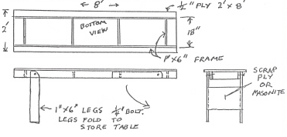

Plywood Usage:
It is suggested that the wing D-tube skins he cut first from 4' x 4' 1/32 (.8 mm) plywood. There is a great deal of scrap cutoffs left from these pieces. Enough to build most of the rest of the glider. They should be cut with the surface grain running spanwise along the wing. One example is shown below. Listed are the necessary pieces to skin both wings.
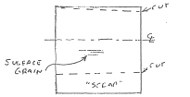

#1 2 sheets 48" long 46" wide at root 40" at tip
#2 2 sheets 48" long 40" wide at root 35" at tip
#3 2 sheets 48" long 35" wide at root 31" at tip
#4 2 sheets 48" long 31" wide at root 25" at tip
#5 1 sheet 48" long 25" wide at root 21" at tip (2 pieces)
#6 ½ sheet 24" long 21" wide at root 19" at tip (2 pieces)

From these cut off pieces we start construction with the tail surfaces.

Horizontal Tail

Ribs:

Band saw or saber saw out the stabilizer ribs from ¼" 5 ply mahogany.

Notch the ¼" cap strips and build up the elevator ribs.

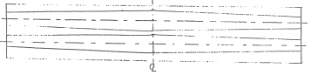
Select pieces of 1/32 birch plywood to lay over both the elevator and main stabilizer spars together. Staple the plywood to the table near right edge and make the necessary scarf joints.

Draw the edge of each span lengthwise and draw the edge of each rib in place.

Saw the notches in the ¼" and 5/16" cap strips as per drawing. Scarf these as shown. Make up the ¼" stabilizer nose cap strips at the same time.

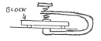
Using the actual ribs as width markers, lay out the webs. Lay the cap strips on the sheer webs and mark down both sides. Now glue the cap strips to the sheer web. Using some long reach clamps, or if necessary, staples and rubber bands.
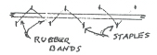

At the center just bend the caps. No cut or joint is necessary.

Glue in the verticals shown on the drawing. Remove from the table and trim sheer web flush with the caps.

With the stabilizer flat on the table, glue the ribs to the spar. Bend the front spar caps to the necessary curve and glue in place.

Cut the front sheer web to size, notch at ribs, and glue in place. I use wooden clothespins for this kind of clamping.

Draw the trailing edge full size on your table, scarf the plywood pieces and balsa pieces, and glue it all up at once using staples for pressure.
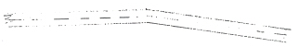

Elevator:
Assemble the elevator with the spar flat on the table, glue the ribs in place and the trailing edge on at the same time. Keep everything straight.

Installing Carbon In The Caps:
Cut a notch in a tongue depressor stir stick. Mix a 1" deep batch of epoxy in an 8 oz. plastic cup. Use the notched stick to force the carbon to run down through the epoxy and squeeze out the excess as it comes out of the bath.

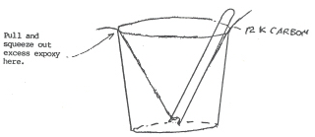
Lay the carbon in the notch and with a small squeeze-out about the width of the notch, squeeze down into the notch, working from the center out both ways. Below is a chart of the amount of carbon for each spar. Same amount both top and bottom.

Hinges:
A sample of a finished male hinge is shown on sheet 6 of the drawings. The raw stock for all 8 tail hinges including the elevator horn are made at one time using a jig 30" long.

The jig is made from 3 pieces of any wood. 1 piece 3/8" x 1" and 2 pieces ¾" x 1". These pieces, as well as the table, are covered first with plastic and then with peel ply. Note rounded corners.
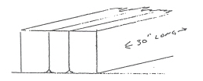

The carbon cloth required in the jig is shown below.(7 pieces)
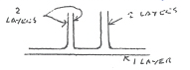

Use 5.7 oz. carbon cloth. Measure out the pieces, allow a little extra, and put a strip of ½" masking tape down the line. Cut down the middle of the masking tape, otherwise the cloth will fall apart when you pick it up. Lay the cloth pieces on top of a piece of plastic on the table. Pour some epoxy on, and squeeze it thoroughly into the cloth. Squeeze off the excess and position the cloth in the jig. With all cloth in place, clamp the pieces of the jig together and down on the table.

Saw the pieces to proper length and to shape as per drawing and drill for 3/16" bolt and 1/8" holes for sewing in place. Locate on spar and drill spar for sewing.

Cut 3/16" bolts to 1 ¼" grip length and grind the last ¼" grip to a smooth taper and glue into hinges.

Using a large hand sewinq needle or sailmakers needle, thread it with a doubled 12k carbon tow and sew the hinges into the spar. The strands near the center go up and around the 3/16" bolt. One bolt(?) needs a 1/16" hole for cotter pin.
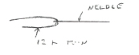

A piece of balsa covered with plastic and peel ply should be clamped to the back until the epoxy has set.

Female hinges:

The jig for making the female hinges is shown on sheet 5. Make from any wood. Coat the jig with epoxy and let it dry. Paint it with water soluable mold release. Slide a 2½" 3/16" bolt through the hinge hole. Using 4 strands of 12k roving, go from the bottom up and around the bolt and down again on the left side. (Total 8) Go up, around, and down again on the right side. Then, the same on the slant side. Slide the two halves together and clamp. Pull the carbon tight around the bottom and clamp the whole jig down on the table over peel ply and plastic.

When set, remove from mold, clean up the flash and drill 1/8" holes for sewing.

With the elevator hanging, trailing edge down on some blocks off the edge of the table, slide all the female hinges in place on the male hinges. Clamp these hinges in place, slide the spar off, and drill the spar for sewing holes. Sew these hinges in place.

Elevator Horn:

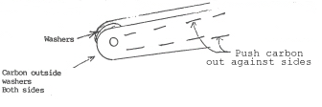
To reinforce the elevator horn, slide a 3/16" bolt in the drive hole with 3 washers inside. Run 3 double strands of 12k roving down each side the horn. Push a piece of ¼" balsa down inside to hold these rovings out against each side.

Stabilizer Mount Holes:
From any ¾" wood, make two jigs to hold 3/16" bolts. One with holes 10" apart, one 4" apart. Using these jigs, with a 2"
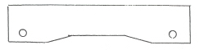
3/16" bolt in place, mold the female fittings on the spars around these bolts. Use a washer on the other side, and clamp to force the carbon into the hole around the bolt. Clamp a piece of balsa protected with plastic and peel ply against the carbon on the spars.

Elevator D-Tube:
Make the rings that support the D-tube. Glue in place on the spar. Cut the plywood to approximate size. Soak in very hot water and bend to curve. Let dry and install one piece at a time. Join the pieces using a doubler inside about 1" wide. Mark the location of the hinges to cut out later. Cut a "T" shaped hole in the D-tube for each hinge.

Gradually file or sand out the "T" notch to allow 30° travel each way, then glue in a plywood doubler ½" wide. These are the 5 stops at the control surfaces.

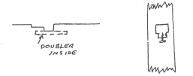

Trim the D-tube to the pattern at the ribs as shown and cover it with one layer of 3/16 oz. fiberglass with the weave at 45°. Overlap about 2" at the center rib.

With the stabalizer and elevator assembled, install the 1/32" plywood gap cover along the main spar and ribs of the stabilizer.

Covering:
Use Stits hs 90 x 1.7 oz. dacron. The elevator is covered with the weave at 45° to the spar for added tortional stiffness. The stabilizer at 90°. Glue covering to all ribs and heat shrink slowly, one side and then the other. Brush on two coats of non-taughtning nitrate dope.

If you like, you can glue on ¼" balsa at the tips and round slightly. But remember, when you think of adding anything, the basic principal is, go out in the yard and throw it up in the air. If it comes down, it's too heavy.

Vertical Tail:

Spars:

The building of the vertical tail is so similar that explanation seems unnecessary. Below are the carbon call outs for both spars.

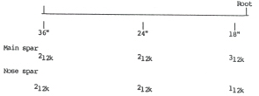

Rudder Horn:
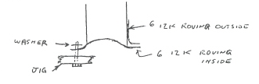
Step 1:

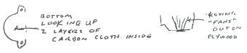
Step 2:

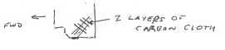
Step 3:

Above is the layup of the carbon on the rudder torque tube for the horn. Use peel ply at each step, so no sanding is necessary between layups. When the cloth goes over the bolt on the jig, as it all does, just use an awl to push the threads aside. Clamp a washer over each layup around the bolt. (See Sept 95 Sailplane Builder p6)

Wings:

Carbon Spar Caps:
The spar caps are carbon "box" sections built up inside a spruce box. They are built flat on the table. Start by laying out 1/32" plywood along the table 22' 3" long. Cut the plywood 7½" wide and all 4 caps are built on this plywood top. Scarf the joints, and staple to the table so it doesn't move until all 4 caps are finished. Now the sides of the 4 boxes are made up. They are 3/16" spruce and 22' 3" long. The depth of the boxes are shown in the cross sections of the boxes shown below. The four "plugs" that go in the middle of the carbon should be made up at the same time. The corners of the "plugs" should be rounded about about 1/16" plus radius.

The following are the dimensions of the boxes and plug:

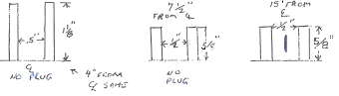
Boxes:
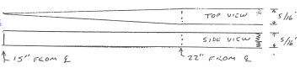
Plug:
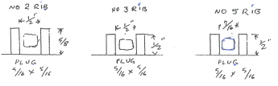
Boxes:

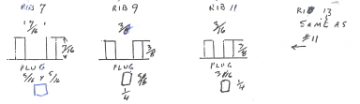

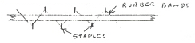
Stretch string tight on the plywood and mark one straight line for each spar cap. Locate the 8 box sides on the plywood and mark for glue, one edge straight along the string mark, the other gradually coming closer towards the tip. You can use rubber bands and staples to clamp the box sides down.

Where the height of the box and the plug change size, sand a taper about 6" long in the larger piece.

Locate the plugs down the center of each box and nail in place with 1 ¼" #18 wire brads. These brads should be on 10" centers and driven into the table about 1/8". They hold the plug in the center of the box. Remove the plugs and set aside. Be sure to mark them so the same plug goes into the same box. After half the carbon is in place, the nails are pushed down all the way. They are then located in the pre-made holes, tapped lightly into place, and the plug slid down the brads into the epoxy-carbon. Then the second half of the carbon is installed, going around the brads.

Installing the Carbon:
Carbon roving is sold by the k count. 12k roving being 12,000 carbon strands. The following discussion assumes using four rolls of 12k roving. Obviously, 6k or lOk or any count will do as long as the correct total is installed. Between 2" and 1O" past the root end of the spar caps, drive about 15 small nails into the table or into a l"x4" extending beyond the table. The nails should slant away from the spar end. Each "pull" of carbon is fastened to a nail and pulled tight toward the tip, then dropped into the spar cap box. All squeez.ing can be done from the root toward the tip and it will keep all the carbon straight.

Hang 4 rolls of carbon up together near the tip end of the spars so they turn easily. Thread the four rovings through a ½" hole in a nylon block, then thread through the epoxy bath (see drawing sheet) and through the squeeze block with 1/8" hole. Pull out the carbon and walk with epoxy bath to the root end. With a slip knot, tie the carbon to one of the nails. Fill the hath with mixed epoxy and walk back toward the tip wetting out the carbon and dropping it into the spar box. Cut the carbon just past the spar tip. Walk back to the rcot, pulling out carbon. Fasten to a nail, and walk back to the tip again and cut. You now have 2 "pulls" in the box. A "pull" being four 12k strands.

The chart below shows where to cut the end of each "pull" so that you have the oorrect amount of carbon in the spar caps.

Put the first "bottom" carbon in first. Then drop in and nail the the plugs. Push down into carbon and install the top half of the carbon going alternately to left and right of the nails.

The numbers are number of "pulls". Each is 4 strands of 12k roving.

Top | 12 | 11 | 10 | 9 | 8 | 7 | 6 | 5 | 4 | 3 | 2 | 1 | 0
Rib-CL | 1 | 2 | 3 | 4 | 5 | 6 | 7 | 8 | 9 | 10 | 11 | 12 | 13
Bottom | 11 | 10 | 9 | 8 | 7 | 6 | 5 | 4 |  | 3 |  |  | 2
Totals | 23 | 21 | 19 |  | 15 |  | 10 |  | 6 |  | 3 |  | 2

Now, from 22" out from the CL(center line), where the plug begins to taper, on to the CL, just cut short sections of carbon and fill the box level with the top.

Pull the carbon tight toward the tip each time and squeeze from the root toward the tip after each "pull".

The result will be that around the tip area most of the carbon will be at the outside of the spar around ribs number 8 and 9. You will have carbon at both top and bottom.
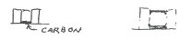

From about rib number 5 inboard, you will have a carbon square tube
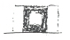

The spar caps can be removed from the table and the plywood trimmed flush with the sides of the caps but store them straight. Epoxy continues to post cure for many days and you don't want any curves.

Wing Ribs:
The wing ribs should be made next. The #1 root nose rib is made from two layers of ¼" 5 ply mahogany. All other ribs from one piece of ¼" 5 ply mahogany. The root rib and ribs number 3, 8 and 13 have 1/32" plywood sheer webs.

Center Ribs:
The center ribs are made from 5/16" square spruce with the inner supports made from 5/16" x ¼" spruce. The root rib has a sheer web of 1/32" plywood on the outside and should get only one inner support, vertical and 8" from the spar. It will get a second vertical on the installation of the drag spar later. The #2 rib should get 2 diagonal but no vertical until the drag spar is installed.

Leave this area clear in #2 rib.
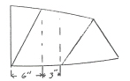
With the ribs and spar caps complete, we can assemble the wings. (The table should be 2' wide and 22½' long.)

Mark the width of the two sheer webs on the table and cut out the necessary pieces of 1/32" ply. The grain must run at 45° as shown below.

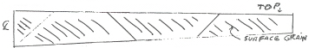

You can just butt the joints with a piece of plastic under each joint. After the spar caps are glued in place, glue a 1" wide strip of 1/32" plywood over each joint between the spar caps.

Mark the location of each rib on the sheer web after it is stapled to to the table. Stretch a string down the center, spanwise, and mark. At each rib, mark the width of the spar. Place the spar caps on the sheer web and mark the inside for glue. Glue the spar caps to the sheer webs, using long reach clamps and blocks of 1x2.

Assembly:
With the wing spars flat on the table, sheer web down, mark the locations and glue the wood nose ribs in place. Glue in the verticals as shown on the drawings. Leave the foam ribs until later. Glue in the 5/16" square nose stringer.

Clamp seven 1x2 boards on edge to the table and extending out on each side about 15" at root end, and 8" to 10" at tip. Turn the spars over and let the nose ribs hang dcwn on each side of the table.
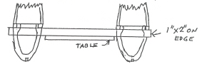

Locate the mid-ribs and glue to the spars. Use string to align ribs. Next, build up the rear aileron spars on the back edge of the ribs.

D-tube Skin:
Turn the wings over and hang over the sides of the table, nose up. Lift the wings 2½" above the 1x2s and clamp the ribs to the 1x2s. Take your time and make sure they are even with no twist.

Now, using a long straight edge, at least 6 feet long, sand the wood ribs to contour. It may be necessary to shim out one or two. With the wood ribs in good alignment, install the foam ribs as shown on drawing sheet 7. Then sand these to contour.

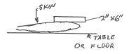
Start with the wing tip D-tube skin. Soak in hot water and bend in the nose curve. I just clamp the aft edges and put between two 1x6s with some weights on top.

The gentle curve aft of the sharp nose curve is no problem. When dry, fit the skin in place, pull tight with a few rubber bands and drive one small nail into the nose stringer at each end. Cut off the nail head and use as a jig. Remove the skin by lifting off the 2 nails. Mix epoxy and pour on and squeeze off the whole inside surface. Leave no excess, just a coat of sealer.

Now mix flox with epoxy and coat the ribs, nose stringer and spars. Mix very stiffly and lay it on thick, about a 1/16" ribbon on all surfaces. Then, drop the skin back over the 2 nails and staple. To locate the ribs exactly, hold a 200 watt light bulb inside the wing. You can see the ribs through the skin and with a pencil, mark exact location of each rib. Start stapling at the center and work outward and down, placing staples about ¾" apart. Staple nose stringer, wood ribs and two rows at spar to wood, each side of carbon.

Next, using "C" clamps, add a 1 ¾" doubler inside the edge of the skin. See detail near rib #3 drawing, sheet 7. Fit the next skin. Mark rib locations using lightbulb. On 1 ¼" centers, drill 1/16" holes through second skin and doubler. Remove skin and redrill holes in skin only to 1/8". Clean up both 1/8" holes in skin and 1/16" holes in doubler. Squeeze epoxy on skin, add flox-epoxy to wing and install second skin. Pull a rubber band tight over foam rib. Now install a row of #6 ½" sheet metal screws in skin and doubler. Tighten gently to pull skin and doubler together. When cured, remove the screws.

Skin the wings from the tip to just outboard of rib #3. Then stop and install the drag spar as shown on the drawings. The wood for the drag spar is shown on drawings number 7 and 9 and seem self-explanatory. The minimum carbon needed is 1/8" x 1/8" and the boxes exceed this, so just fill the boxes.

With the wing flat on the table, install the carbon. At the outboard end, the carbon is fanned out about 1" wide and spread out over the spar where the 1/32" wood skin has been sanded away. At the wing root end, bring the carbon around the wood fitting. Turn the wing over and bring the carbon around the fitting again. Around most of the fitting, you will have double the carbon needed. Install 4 layers of carbon cloth on each side of the root fittings, extending out on the rib about 1".

After the drag spars are installed, clamp the wings off the sides of the table again and add the last inboard D-tube skin.

Mating Wings And Flaperons:
Unless you're a lot better or luckier than most, the wing and flaperon are not going to fit exactly. You will have to use shims at a few of the hinges. I suggest, with the two pieces clamped in place, you stretch a string along the hinge line and use this as a guide to decide whether to shim on the wing or flaperon. All these hinges are shown on sheet 10 as in the sewing pattern. These are sewn in with fiberglass roving. The 1/8" holes should be a little over half full of wet fiberglass and each should be clamped while wet with a balsa block protected with plastic and peel ply.

Add the wing tip skids and the flaperon mass balances. The lead weights are .75 pounds with the CG 6" forward of the hinge line.

Install the control horns. They get 4 layers of carbon on each side. The inboard carbon extends along the spar edge and bottom of the #1 rib about 1½" on the inboard surface of the rib as shown on drawing sheets 10 and 11.

Covering:
The flaperons are covered with 1.7 dacron with the threads at 45°. The wing with cloth at 90°. Keep the finishing weight to a minimum.

Flaperons:

The flaperons are made with carbon and covered with the dacron at 45° to keep them stiff enough.

Ribs:
To prepare the raw stock, cut the notch about 3/32" square in 30 pieces of 5/16" square spruce cap strip 5 feet long. Drive 2 rows of small nails into your table ¾" apart and the rows 6 feet apart.
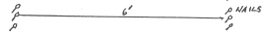

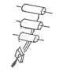
Lay the spruce strips between the nails and hang up 3 spools of 12k carbon roving so you can pull them off together. Pull out the roving through the epoxy bath and tie the end to the nail.

At the other end, fasten the wet rovings to a 1/8" rubber band and put tension on the carbon. Squeeze the carbon down in the notch. Total of 6 12k each strip. When set up, remove the stock and build up the ribs. Put the drawing on the table and plastic over it. Trim the ribs to fit and assemble. All verticals are 5/16" x ¼" spruce.
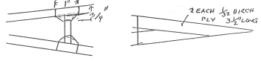

Ribs #2 through #15 get verticals. #16 through #27, none. #28 is solid ¼" mahogany 5 ply, no carbon.

Flaperon Spar:

Use 5/16"x3/8" cap for the spars. Notch same as ribs. Then run over table saw to get a 10 degree bevel.
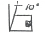

Lay out near one edge of the table, the two sheer webs and scarf all the joints. Mark the C/L on each, and using the wing ribs as a measure, mark off the width of the spar caps. Mark both sides of each cap for glue. Glue the flaperon cap strips to the sheer web. Hang up your carbon again and put 6 each, 12k rovings in the spar caps. Again, use nails in the table and rubber bands to put tension on carbon until it sets up.

To make the trailing edges, cut 4 pieces of 1/32" birch ply, 2" wide and full length, say 21.5 feet. Scarf all the joints and staple 2 of these to the table. Put staples near on edge. Get it straight with a tight piece of string.

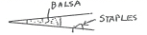

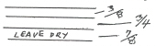

Paint and squeeze the pieces on the table with epoxy, leave dry the area that glues to the ribs.

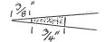
Hang up your carbon again, 2 rolls this time, and lay the 2 strands of 12k along the middle of where the balsa goes.

Balsa trailing edge stock from
model shop 1/16"x¾"x3/16"

Try not to twist the carbon. When you squeeze this flat, you should have a ribbon about 3/8" to ½"' wide.

Now, paint the balsa with epoxy and lay it in place on the carbon. Drive a row of really small nails along the balsa on about 8" centers.
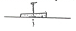

Drive into the table about 3/8".

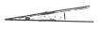

Now, snip off the nails close to the top of the balsa
and drive down flush with the balsa.

Now, lay the second, 2 each, 12k roving on top of the balsa, and the third aiong the back edge of the balsa and glue on the top piece of 1/32" plywood using a lot of staples. You can twist this one a few turns to get a "rope".

Detail for building trailing edge for flaperon - Side cross section
The following diagram was contributed by Steve Adkins and is not a part of the original manual, but should assist the builder to understand this part.
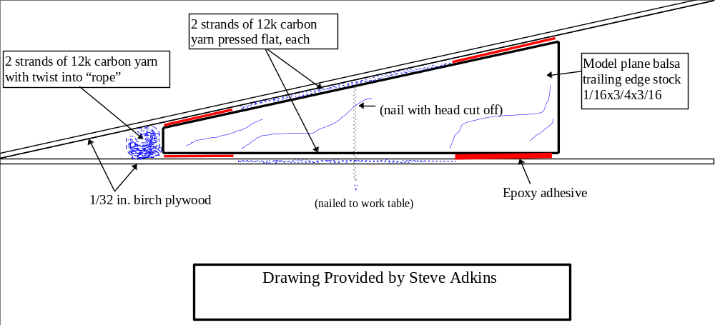

Leave these on the table until your ready to install them. All epoxy layups "harden" in about 24 hours, but they gain about 1/3rd their strength in post cure. Where else could you put them and keep them straight? Incidently, about half the nails will stay in the table and about half in your part. Never mind, you can pull all later.

Clamp 1" square block to your table and 2 carpenter squares to these blocks right on the flaperon CL at the root.
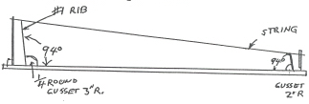

Rig any jig at the tip end about 7" high and stretch a piece of kite string. We mount every rib so it is dead center on the string. We glue the two inside gussetts in place on the spar caps and all the others as we go.

Now prop up ribs #2 and #3 and "C" clamp the inside gussett in place. Go back and forth to the disc sander until they fit right and the tip ends are ground off to the right angle and width. Now glue ribs #1, #2 and #3, and the gussetts all at once. Keep the CL of the ribs right on the string. Glue a little balsa block in the 45° angle at the tip of ribs #2 and #3. Glue it in with quick setting model airplane glue and spray with quickset. It's solid in 20 seconds.
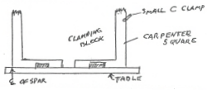

When all of the ribs are in place, remove the trailing edges from the table and glue them on. Use plenty of glue and pull down at each rib with a rubber band. Glue 5/16"x1" blocks for the hinges as shown on the drawing. Block for #1 hinge, 7" long. For #7, 4" long. #2 through #5 are 3" long.

Now, install the plywcod "skin" along the forward edge. Scarf at each joint. Now trim both the trailing edge and the root skin to scallop shape.

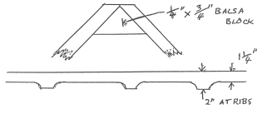
Glue in verticals, all 5/16"x¼", to the sheer web as follows:
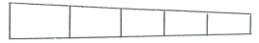
1. At every rib.
2. From #1 to #7 and #8, add two verticals between ribs.
3. From #7 and #8 to #15 and #16, add one between ribs.
4. Outboard of #15 and #16, none between, just at ribs.

The aileron is now finished, except the horn and the lead weight at the tip. Another chapter.

To clamp these cap strips in place, use this, unless you get a better idea.
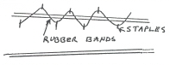

You have to go back and straighten the cap between your pencil lines after putting in these rubber bands and staples.

Flaperon Ribs:

1. Ribs stock: 5/16"x5/16" square spruce with notch and 6 each 12k carbon, roving each.

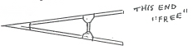
2. Ribs: Build up

3. Verticals in ribs #1 through #15. None #16 to end.

4. #1 and last rib gussetts on one side only. They get 1/32" ply, full skin on outside.
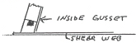
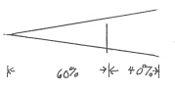
5. Locate verticals at 40% from root.

Assembly Of Ailerons:
1. Lay out sheer webs on table.
2. Glue notched 3/8" x 5/16" spar caps to sheer web. Note 10° bevel angle.
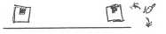
3. Install carbon in spar caps, 6 each, 12k roving.
4. Mark location of rib joints on spar caps.
5. Inside gussetts are 1/32" ply, 1¾"x3½". Glue these in place to the spar caps.
6. Stretch a string the right height above table to keep rib trailing edge straight. Cut rib root ends to 45° and install ribs. Glue and clamp to inside gussetts. With model airplane hot glue, fix outer ends of ribs together with ¾" x ¼" balsa blocks.
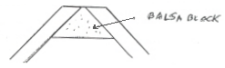
7. When all ribs are in place, glue on trailing edge.
8. Outside "gussetts" are one long scarfed-up 1/32" sheet.
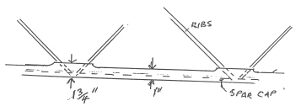
9. Before removing from table, it remains to install the verticals and hinge blocks.
a) At every rib joint, the spar gets a 5/16 x 5/16 spruce vertical.
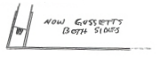
b) From the root to rib joints #7 and #8, two 5/16" balsa verticals equidistant.

c) From rib joints #7 and #8 out to rib joints #17 and #18, one 5/16" square balsa vertical in center.
d) Outboard from rib joints #17 and #18, no mid verticals.

Tail Boom:

Longerons:
The longerons are made, all 4 at once, of two 3½"x3/16"x13'2" spruce planks and orcoweb carbon. Orcoweb is unidirectional strands of carbon held in a ribbon by small cross stiches of fiberglass glued in place. You can buy it in a 3" roll or buy 12" wide and bandsaw while on the roll to 3" wide. Cover 12" of the table near one edge with plastic. On top of one 3/16" plank, lay out one layer of orcoweb. Pour epoxy on and squeeze lengthwise to spread the epoxy and wet out all strands. Leave excess epoxy, lay on the next layer, squeeze and add epoxy as necessary. Lay on layer 3, etc. The total orcoweb is as shown below
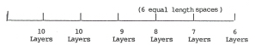

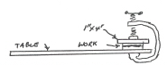
When all orcoweb ls in place, put the second 3/16" plank on top. Put a 1x4 on top of that and clamp with "C" clamps.

Tighten "C" clamps slightly, wait 2 minutes to allow epoxy to run out sides, tighten again, wait again. Finally, don't use excessive pressure. Very messy. Lots of epoxy runs out = a good laminate.

Finally band saw or table saw out the 4 longerons, avoid the very edges.
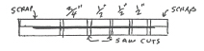

Mold:
Next, build the mold. Sides should come up vertically about an inch above center. Mark in the mold, above center, the location of each bulkhead and longeron. I lined my mold with 1/32" formica but aluminum would be better.

Bulkheads:

Now saw out the ¼" bulkheads. Saw slightly wild and sand so they fit nicely into the mold at each station with some clearance.

Graphite Cloth:
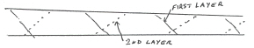
The graphite cloth I used is 5.7 oz. and normally .007" thick. The tail boom gets two layers, so theoretically, .014" thick. Both layers of cloth are laid in at 45°. Wax the mold and spray with water soluable mold and release. Cut the pieces of cloth starting the first layer at the root. The second layer starts at the tip.

All lap joints ¾" to 1 ¼".

Put in the first layer of cloth. Pour in epoxy and squeeze out excess. Lay in the second layer, squeeze and add epoxy as necessary. Then, lay in and squeeze in place a 2" wide peel ply, tape at each station and along each longeron location. After epoxy sets up you can fit the frame in one final time.

Now, take the assembled interior structure of frames and longerons, with pulleys installed, and glue this into the first half of the skin. The glue is done right in the mold. Note: The skin should be parted from the mold first. Then make the second skin.

Assembly:
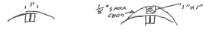
To assemble the two halves, paint on a 1" wide layer of epoxy on the skin at all joints, then mix epoxy and flax so it is just stiff enough to stand. Trowel this about 1/16" thick on longerons, all frames, the skin joint and join the two. The second skin just overlaps the first about 1".

We put a 1x1 stick along the joint full length and wrapped the whole thing with a lot of rubber bands. Later, sand slightly and add a 2" fiberglass tape over this joint.

Note: All composite layups gain in strength and stiffness in the post-cure period after original hardening. So final cuttinq and/or mating is best done a day or two after making, not a month later.

IMPORTANT: Run either the 1/16" control cables or at least some strong string full length in the tube for controls before joining skin halves. If you don't, I have no idea how you can install these later.

Tail Cone:
The tail cone with elevator pulley can now be installed. The fin stubs are best installed with the fin standing or in place. If you install the fin now, you'll have endless fun turning things over many times as construction procedes.

The skin at the front of the tube is trimmed flush with the frame and the hole in the pilot pod frame #55.5 is cut to fit. The joint here is finished with two layers of 902 glass on each side.

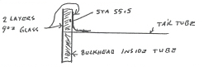

Control Tubes

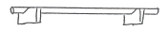
The carbon control tubes are made as follows over any aluminum tubing. The thinner the wall, the better. One short 1" torque tube, cut a piece of carbon cloth about 18"- long by 43" with threads at 45°. Measure the size and stick a ¼" strip of masking tape along the lines. Cut down the middle of the tape. Cut the aluminum tube over length and support it in two notched pieces of scrap wood. Tape one of the edges of the cloth to the aluminum tube. Now paint on epoxy, squeeze, and turn the tube ¼ turn. More epoxy and squeeze and turn. Try to keep the cloth fairly tight. When all carbon is in place, start at one end and wrap with 1" peel ply as tight as you can. Lots of epoxy will squeeze through the peel ply. Great. Wrap all the way one way, wipe off excess and wrap again from opposite direction.

When cured, remove peel ply, saw off ends a little wild, next make a box or lay out some bricks and put plastic inside. Drop tube in, tilted slightly one end up, and fill half full of water, then pour second half full of swimming pool acid. Always pour acid into water, not visa versa. It may take two or three treatments to get all the aluminum out depending on aluminum wall thickness.

Call outs for carbon on the tubes are as follows. Wrap length

1. Short 1" tube 43" 45°
2. Long 1" tube 18" 45°
3. Control stick 5/8" tube 12" 90°
4. All push rods ½" tube 14" 90°
(Bend these aluminum tubes as shown on drawing sheet 20 before carbon wrap)
5. Tailwheel Mount tube ½" tube 14" 90°
The stick connecting the two seat hooks and the stick that controls the rear door can just be made of 3/8" square balsa wrapped with about three or four layers of carbon.

Rudder Pedals:

The rudder pedals are ¼" 5 ply mahogany. Cut out center, put in ¼" foam, 1 layer 9 oz. glass on feet side, and one layer 3 oz. glass forward side.

Wheel Brackets:

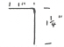
The hook brackets and main wheel brackets can all be made at one time.

See drawing on sheet 18.

Pilot Pod:
Building the pilot pod seems to be pretty self-explanatory. The two lower longerons must be made first on the table, propped up to the proper angles in both planes. There, the carbon is put in. The other longerons should be soaked with hot water and bent to the curves flat on the table. Then the pod can be assembled. The top and outside skins can be put on. Install the inside skin after all control systems are in. Skins are 1/32" birch with outer grain as shown below.

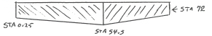

Kevlar:
You need 3 feet of 12" wide unidirectional kevlar. Separate out the kelvar strands as you need them. Use four strands in each location shown on sheet #4 or #6 at the wing lift points and the forward diagonal. Stagger the ends 1". Kevlar has superb tensile strength and these are all tension points.

Tail Wheel Spring:

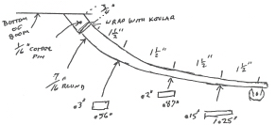
Following is an improved tail wheel spring. Better than that shown on Sheet 12.

This spring is made up of a constant volume of fiberglass rovings, but the shape changes.

Doors:

When the pod is assembled, but before it is skinned, turn it upside down and build the two doors. Cut and fit the two sill pieces. Put the hinge in place and shim forward on that side to the thickness of the hinge. Glue the door frames in place, bend the keel plate with hot water to the necessary curve on the table. Glue the keel plate in place. Fill the forward cut out with a piece of ¼" 2 lbs./3 ft. foam. Get enounh 3/16" x 1" balsa strips to plank the door. Either get these cut from a single block of balsa, or choose them carefully at the model shop so they are all about the same density. If you glue a hard piece next to a soft piece, sanding becomes difficult. As I remember, I bought 3" wide planks and ripped to 1" with a knife. Start at the outer sills and at the center at the same time. Tapering will be necessary to finish up. I used Elmer's Carpenters Glue. Use it sparingly and don't worry about small gaps. When planking is finished, turn the door over and where there are gaps, cover them with a ¼" or 3/8" piece of masking tape so epoxy won't run through. Then glass the inside with 3 oz. glass. Run the glass ½" up on each frame.

Cover the pod with plastic and clamp the door in place with small clamps inside. Now, sand the outside to a nice contour. Try to keep at least 1/8" of balsa everywhere. Now glass the outside with one layer of 9 oz. glass. Put a piece of 4" peel ply down each side. On the left, 6" past the hook locations, fore and aft on the right, 6" past the hinge. Now, sew the hinge in place to pod and door. Put peel ply over the stiches. Finally, add a second strip of 9 oz. glass over the stiches and along the hook line.

Remove the door and install the wheel box seat supports. Trim to fit and install the two seat pieces and the hook rollers. Put in the wheel and brake. Install the hooks in the pod. Run a 2" strip of 9 oz. glass along the seat joints.

Then, build the rear door. Be sure the sill pieces are fully bent to fit. When you heat shrink the dacron, clamp door in place. The shrinking dacron wants to distort the,door. The stick that drives the rear door is set at an angle so when the main door is open 180° the rear door is open even more. Clamp this stick in place and try it a few times before lashing the stick in place permanently.

Pulley Brackets:

The control system uses three AN 210 (2.5") pullies, two in the elevator system, and one in the flap system. Mounting these seems self explanatory in the drawings. The controls also use the following AN 210-1A (1.25 ).

Rudder | 4
Elevator | 4
Flap | 3
Wheel Brake | 1
 | 12

The brackets for these are made as follows.
Shape a piece of plywood or wood 12" long and 5/16" thick, 3" wide. Round the edges. Wrap with plastic then peel ply. Staple these in place. Now wrap with six layers of carbon cloth. With peel ply and plastic, clamp flat to table to cure. Saw up into pieces as shown.
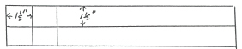

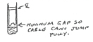
Makes 16 pieces or 14 with some scrap at ends. You might louse up one. When separated, glue a piece of ½" round in each. Then drill the hole for center of bearing.

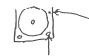

Hole for cotter pin
keeper where necessary

Now 1/8" holes can be drilled for sewing and gluing into place.

The flap control stick is made in a simple female mold. Only the width is important. It is made with a constant volume of fiberglass roving, but approximately ¼" square at the top, and thinner but wider below. The springiness of the fiberglass keeps the control in each indentation. When mounted, the control should bottom out firmly in each setting. It should take 1 to 2 pounds push pressure at the top of stick to move it out of indent.

Canopy:

Frames:
The 1/32" plywood will take the bend with no preparation. The balsa must be pre-bent with hot water. Draw the complete frame on the table. Drive a row of 2" nails along the contour on about 2" centers. Bend the balsa along the nails and clamp in place with clothespins. 1" finished width is adequate for all three canopy bows.

Drape one piece of 1/32" plywood over any plank with a "C" clamp for weight at each end. Lay on 4 strands of carbon roving, wet epoxy. Lay the pre-bent balsa in place and clamp at ends. Lay on four more carbon rovings on balsa, then add the final 1/32" ply. Clamp ends. Now with several clothespins in place, put the whole assembly on the table inside the row of nails, and clamp to nails and together. Use a lot of clothespins, that is, almost touching.

The canopy sills are two pieces of ¼" x ½" spruce. They are laminated together with the same curve as the glider sill line. All canopy "glass" is .040 lexan. It is installed by drilling lexan and frames on about 2" centers with a 1/16" drill. Remove and debar holes. Drill lexan holes out to 1/8". Debur again. Mask canopy to frames and sills using small screws for glue pressure. Finally, remove all screws except a few at the corners. The forward canopy is built permanently onto the glider and the instrument panel hung from it. If I was doing it again, I would get a hang glider instrument package from Richard Ball and save some weight. It includes audio in the vario. As a matter of fact, I had saved a Wil Scheman Mechanical vario from a glider I sold and it is great. The wisdom is, scrimp on everything else but buy the best vario you can afford.

As you can see from the drawings, our aft canopy is open about 6" forward and about 10" aft. This gives a lot of elbow room for foot launch. With the plywood curved lip on the fuselage at the rear of the canopy, the drag loss is minimal. Our only probiem has been hot shot pilots who jump in to fly on a warm day on the desert floor wearing only a T-shirt. An hour or so later, and a few thousand feet up, they get cold. I think we'll leave this to builder's choice.

Nose Cone:

Incidently, the nose cone shape is only outlined. This is builder's choice also. Here are three examples. Variation in drag on 1 and 2 is about the same at our Renolds nombers.
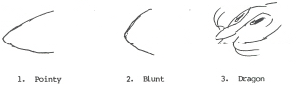

Tow Hook:

The tow hook is designed with a safety factor built in. As long as the pull is forward or only slightly down, it operates as any tow hook. When the tow line reaches about 70° below horizontal, the hook opens automatically. It is not possible to exert excessive down loads on the glider.

Stabilizer Brakets:

The stabilizer brakets are moulded right on the tail boom.
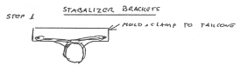
The call out is 30 strands of 12k rovings. Use 3 rolls of carbon, so 10 strands. These can be twisted about a half turn in 6" to make a rope that is easier to handle. About half should go right around the tail boom and half just straight across. Use the same mould that was used on the stabilizer so things will fit. Leave pins out ½" to wrap. When all carbon is in place, push pins in snug.
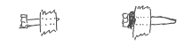

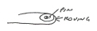

Half the rovings should wrap clear around the pins once.

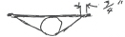
Step 2:

Use 8 3-strand 12k rovings for the diagonals. Pull tight and wrap at ends with peel ply. When cured, remove peel ply and wrap with kelvar.

Measure from the stabilizer to locate the forward pins. These pins should be 3/8" longer so at assembly, they engage first. The aft pins are drilled for cotter pins.

Materials:

Almost all the materials used in the prototype were obtained from Aircraft Spruce, Box 424, Fullerton, CA 92632. A few exceptions were the main wheel is an 8" sailplane tailwheel. The flaperon quick disconnect fittings are from McMaster-Carr, Box 54960, Los Angeles, CA 90054. Catalogue info is ¼-28-9/16-6058K-32.

Foot Launch:

For foot launch, here is an aileron-rudder interconnect using springs. After launch, a downpull on the cotter pin releases the interconnect. Small 1/8" shock cord moves fitting free.
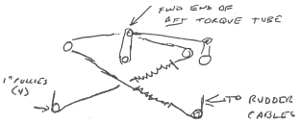

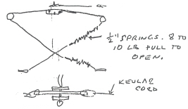
Looking Forward

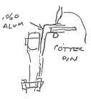

Looking Down

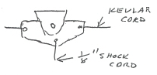

Side View:

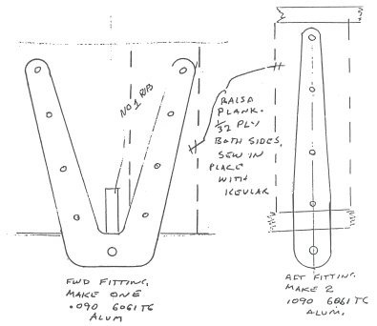
Improved Stabilizer Mount Brackets:

Install mount pins aft on tail tube first. Sew around top longeron as well as to tube.
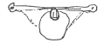

Mount aft fittings to mate with pins.

Mount forward fittings in stabilizer.

Locate forward pin and glue in place on top of a piece of balsa with instant model glue.

Sew in place with carbon. Cut out balsa and sew around to a longeron.

Spoiler:

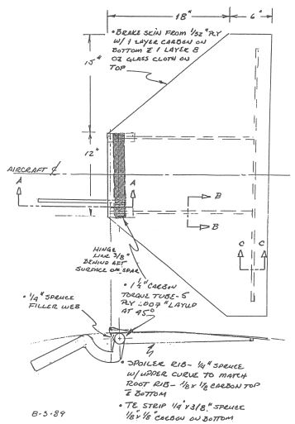
Top and Side View:

Detail A-A:
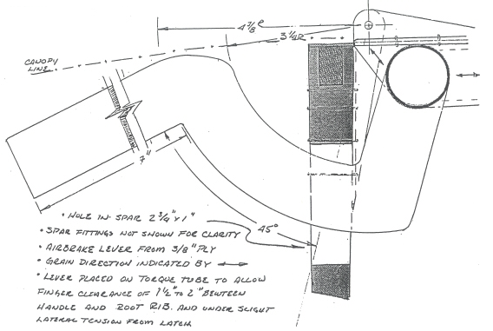

Spoiler Hinge Detail:
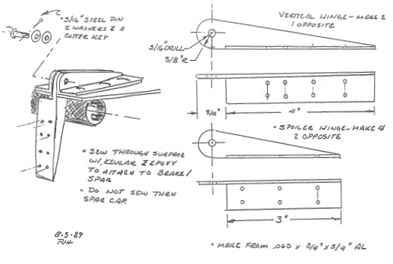

Spoiler Lever:

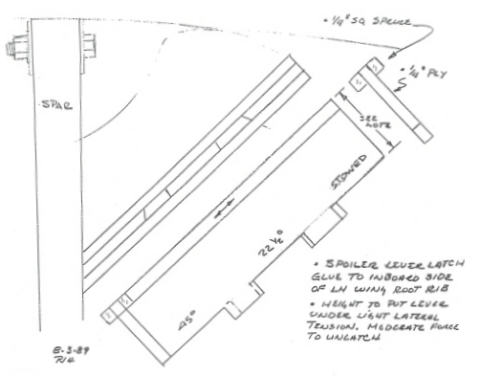

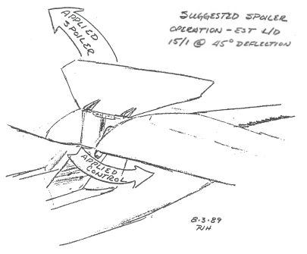
Spoiler Operation:

Detail B-B:

Detail C-C:

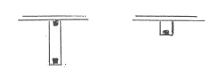

Flight Envelope:
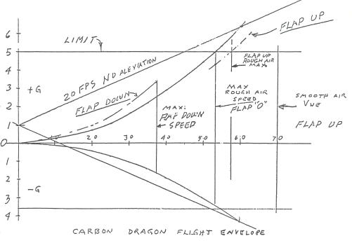

Glide:

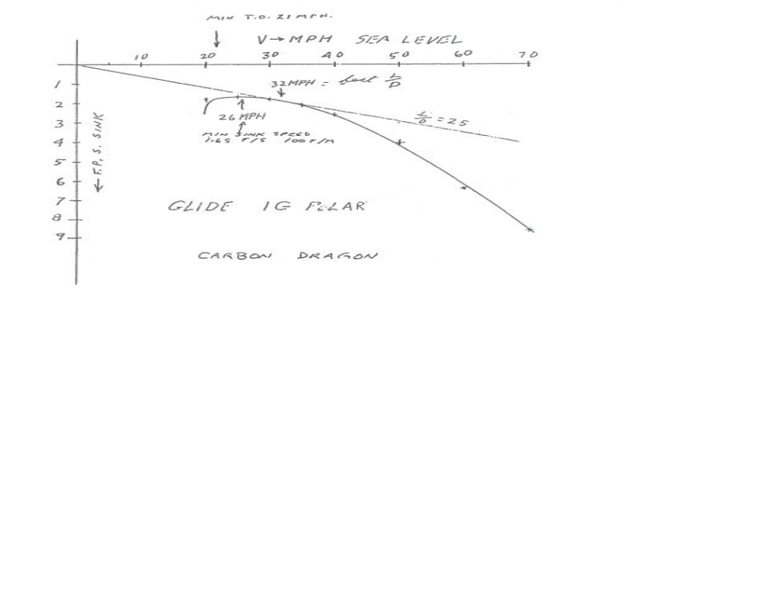

Flight Limitations:

 | NORMAL | MAXIMUM
 | 5 G Limit Load | 4 G Limit Load
Minimum Weight Pilot and Chute | 120 lbs | 120 lbs
Maximum Weight Pilot and Chute | 155 lbs | 190 lbs
Maximum Speed - Flaps Down | 38 mph | 35 mph
Maximum Ground or Aero Tow | 38 mph | 35 mph
Maximum Rough Air Zero Flaps | 50 mph | 45 mph
Manouvering Zero Flaps | 50 mph | 45 mph
Maximum Rough Air Flaps Up | 55 mph | 50 mph
Maximum Smooth Air - Vne | 65 mph | 60 mph

Data:

Root Chord | 61.2" = 5.1 ft.
Tip Chord | 22.5" = 1.87 ft.
Span | 528.0" = 44 ft.
Area | 153.34 sq.ft.
A/R | 12.62
MAC(1) | 44.4"
DATUM(2) | L.E. of Root Rib(3)
DATUM of L.E. of MAC | 4.5"
DATUM to 20% MAC | 13.4"
DATUM to 25% MAC | 15.6"
DATUM to 30% MAC | 17.8"
DATUM to 35% MAC | 20.0"

(1) MAC: (Mean Aerodynamic Chord) is the average distance from the front of the wing to the rear of the wing. 20% percent back would be the point at which the glider should balance
(2) DATUM: The datum line is an arbitrary point from which all weight and balance calculations are made. Most often, it is at the very front point of the aircraft (as in the case of the Carbon Dragon). All points back are referenced to this point with a notation such as Former 51.75 (former 51 ¾" back).
(3) L.E. of Root Rib: (leading edge of the root rib) indicates the largest rib at the near center of the wing.

Empty Weight Detail:

Glider Section | Weight in pounds
Wings - 37.5 lbs. each | 75.0
Vertical Tail | 5.0
Horizontal Tail | 8.0
Fuselage | 57.4
Total | 145.4

Prototype:
on July 29, 1988
Weight and Balance Information.

 | Empty Weight (lbs) | Weight With 135 lb Pilot
Main Wheel | 122.2 | 270.2
Tail Wheel | 23.2 | 10.2
Total | 145.4 | 280.4

Measurements:
Main Wheel 12.2" aft of DATUM
Tail Wheel 178.2" aft of DATUM. Main w. Tot. W 166.0"

To Determine Pilot CG(Center of Gravity):
23.2 - 10.2 = 13 lbs
135 lbs x P.CG = 13 lbs x 166"
Pilot CG = 15.98" Forward of Main Wheel
Pilot CG Forward of DATUM is 15.98" - 12.2" = 3.78"

To Determine Empty CG:
(178.2" x 23.2 lbs + 12.2" x 122.2 lbs) / 145.4 lbs = 38.6" aft of DATUM

Maximum Pilot Weight (MPW) at 20% MAC:
MPW x (3.8 + 13.4) = 145.4 x (38.6 - 13.4)
MPW x 17.2 = 145.4 x 25.2
MPW = 213.0 lbs.

Maximum Pilot Weight (MPW) at 25% MAC:
MPW x (3.8 + 15.6) = 145.4 x (38.6 - 15.6)
MPW x 19.4 = 145.4 x 23.0
MPW = 172.4 lbs.

Maximum Pilot Weight (MPW) at 30% MAC:
MPW x (3.8 + 17.8) = 145.4 x (38.6 - 17.8)
MPW x 21.6 = 145.4 x 20.8
MPW = 140.0 lbs.

Maximum Pilot Weight (MPW) at 35% MAC:
MPW x (3.8 + 20.0) = 145.4 x (38.6 - 20.0)
MPW x 23.8 = 145.4 x 18.6
MPW = 113.6 lbs.

Flight Test:

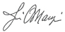
It is recommended that flight tests begin with the CG somewhere around 30% MAC. First tests should be done with auto tow down as long a runway as is convenient and with little wind. Have the tow car accelerate smoothly but fairly quickly to about 30 mph. Just leave the flaps in neutral and tow to about 10-15 feet altitude, release and land. Turn around and tow back. Use 150 to 250 feet of rope. Tow slightly higher and try gentle turns, still landing straight ahead. With confidence, go to a 1000 foot tow rope. With this rope and in winds from 5 to 10 mph, we got endless tows to 400 feet and found we could do a lot of maneuvering. Go back to start and land into the wind at the starting end of the runway. We found little use for the extreme flap settings. Later, we made lots of liftoffs with 2 notches of flaps and most approaches with this setting, occasionally using full flaps on final. Move on from there. Good luck and clean air.

